Attentional mechanisms drive systematic exploration in young children

Nathaniel J. Blanco (nathanblanco@gmail.com)

Department of Psychology, The Ohio State University

1835 Neil Avenue, Columbus, OH 43210

Vladimir M. Sloutsky (Sloutsky.1@osu.edu)

Department of Psychology, The Ohio State University

1835 Neil Avenue, Columbus, OH 43210

Running Head: Exploration and Attention

Word Count: 2997 (including abstract)

Abstract

Exploration is critical for discovering how the world works. Exploration should be particularly valuable for young children, who have little knowledge about the world. Theories of decision-making describe systematic exploration as being primarily driven by top-down cognitive control, which is immature in young children. Recent research suggests that a type of systematic exploration predominates in young children’s choices, despite immature control, suggesting that it may be driven by different mechanisms. We hypothesize that young children’s tendency to distribute attention widely promotes elevated exploratory choice behavior, and that interrupting distributed attention allocation through bottom up attentional capture would also disrupt systematic exploration. We test this hypothesis by manipulating saliency of the options in a simple choice task. Saliency disrupted systematic exploration, thus indicating that attentional mechanisms may drive children’s systematic exploratory behavior. We suggest that both may be part of a larger tendency toward broad information gathering in young children.

Keywords: cognitive development; exploration; decision-making; attention

Attentional mechanisms drive systematic exploration in young children
Cognition changes dramatically in the course of cognitive development, and many of these changes stem from developmental changes in allocation and control of attention. Adults are highly adept at controlling their attention: depending on their goals, they can distribute it broadly or focus selectively on a small subset of stimuli (e.g., Chong & Treisman, 2005). When only a small amount of the available information is relevant, adults tend to selectively focus on that information and ignore the rest (Rehder & Hoffman, 2005; Blair, Watson & Meier, 2009).
In contrast, young children tend to distribute their attention broadly, regardless of task demands, often processing both task-relevant information and information that is not relevant for their current task (Deng & Sloutsky, 2015, 2016; Plebanek & Sloutsky, 2017; Smith & Kemler, 1977). This tendency likely stems from immaturities of executive attention (Posner & Rothbart, 2007), resulting in difficulty attending selectively and filtering out less relevant or irrelevant input.
While these immaturities may be highly limiting for learning in academic settings, it is possible that such immaturities of executive attention can be adaptive (see Chrysikou, Weber &, Thompson-Schill, 2013, for a review). For example, distributing attention can result in superior performance of children over adults in situations when one has to use information that was previously irrelevant (Plebanek & Sloutsky, 2017; Blanco & Sloutsky, 2019).
Therefore, depending on the context, either selective or distributed attention can be advantageous. Selective attention is superior when one is confident that a small portion of the available information is sufficient to achieve their goals. Distributed attention is advantageous when there is more uncertainty about what is important. Distributing attention may be particularly adaptive early in development, since young children have little experience and knowledge about how the world works. By facilitating broad information gathering, distributed attention helps to reduce that uncertainty and build up a rich base of general knowledge. Distributed attention early in life may represent a sacrifice of immediate performance in exchange for information that can be used later. In other words, it seems that distributing attention in young children facilitates exploration. Recent research suggests that there is a tight link between attention allocation and decision-making behavior (Gottlieb, 2012; Konovalov & Krajbich, 2016; Smith & Krajbich, 2018), and perhaps wider attention allocation also promotes wider distribution in action selection.
There are recent reports indicating that four-year-old’s choices are, indeed, highly exploratory (Blanco & Sloutsky, 2019 Preprint). Interestingly, children’s exploration also appeared non-random. This is surprising because decision-making research critically distinguishes systematic from random exploration (Badre, Doll, Long, & Frank, 2012; Daw, O’Doherty, Dayan, Seymour, & Dolan, 2006; Knox, Otto, Stone, & Love, 2012; Blanco, et al., 2015; Somerville, et al., 2017), and converging evidence suggests a crucial role of executive control processes mediated by prefrontal cortex (PFC) in systematic exploration (Badre, Doll, Long, & Frank, 2012; Frank, Doll, Oas-Terpstra, & Moreno, 2009; Blanco et al., 2015; Otto, Knox, Markman, & Love, 2014). Given the protracted development of cognitive control and PFC (Bunge et al., 2002; Casey, Giedd, & Thomas, 2000; Sowell, et al. 1999), current theories predict that young children’s exploration should be largely unsystematic (Somerville et al., 2017). However, there is recent evidence that young children perform systematic (non-random) exploration, although they may not engage in strategic exploration the way that adults do (Blanco & Sloutsky, 2019 Preprint). These findings raise the possibility that young children’s systematic (i.e., non-random) exploration is driven by different mechanisms than adults’ systematic (i.e., strategic) exploration. We hypothesize that children’s exploratory behavior is tied intricately to their immature attention allocation.
The Current Study
The goal of the current study was to test this idea by systematically manipulating attention allocation by manipulating salience of a cue linked to a reward.
We presented children and adults with a simple reward learning task under three conditions in order to examine the interplay of attention and choice patterns across development. The conditions differed in terms of the perceptual saliency of stimuli marking the choice options: a Baseline condition where all options were of equal salience, a Competition condition where the salient option was mapped to the lowest reward (putting reward-seeking and salience in competition), and a Congruent condition where a highly salient option was mapped to the most rewarding option.
Our hypothesis was that children’s tendency to distribute attention promotes distributing choices across the options. At the same time, some form of novelty preference makes it relatively unlikely that, on a given trial, they would select recently selected option. These two tendencies may enable systematic (i.e., non-random) exploration in the Baseline condition. Furthermore, if altering the attentional pattern through bottom-up capture of attention also affects exploratory behavior, we would be able to infer a strong connection between attention and exploratory behavior early in development. In contrast, if attention is not a causal factor in children’s exploratory behavior, manipulating attention should lead to little or no change in their choices.
More specifically, in the Baseline condition we predicted that most children would engage in systematic choice patterns (Blanco & Sloutsky, 2019 Preprint), with few children exploiting the best option. Our main prediction was that this systematic pattern would be disrupted in both the Congruent and Competition conditions.
The exact role of saliency on choices could follow several possible patterns. One possibility was that children’s choices would be driven by largely by saliency, leading them to select the most salient option regardless of its reward value. Another hypothesis is that saliency would instead act as a learning or memory cue, leading to faster learning to prioritize the salient option in the Congruent condition and to avoid it in the Competition condition. In contrast, small to no effects of saliency were expected in adults, who were expected to maximize reward, exploiting the high value option in all conditions.

Method
Participants
A total of 110 4-to-5-year-olds (mean age = 57 months; age range = 48-69 months; 58 girls, 52 boys) participated in the experiment: 36 in the Baseline, 37 in the Competition, 37 in the Congruent conditions. Children did not differ by condition in terms of age, F(2, 107) = 2.01, p = 0.139, η² = 0.04, or gender, Χ² (2; N = 110) = 2.01, p = 0.367. 108 adults also participated (mean age = 19 years; age range = 18-29 years; 60 women, 45 men, 3 other responses): 37 in the Baseline, 34 in the Competition, and 37 in the Congruent conditions. Child participants were recruited from preschools and childcare centers in the Columbus, Ohio area. Adults were undergraduate students participating for course credit.
Figure 1: Trial structure. (A) After each choice, (B) the reward earned for the choice was presented for 3 s, (C) then the next trial began. In the Congruent and Competition conditions one option was represented by a colorful image that changed on every trial, while the other three were represented by lower salience images that remained stable across trials. In the Baseline condition, all four options were represented by stable images of equal salience.

Procedure
Participants completed a decision-making task that was a simplified version of a standard n-armed bandit task, framed as a computer game in which participants asked alien creatures for virtual candy (Figure 1). The goal was to earn as much virtual candy as possible. On each of 100 trials, participants chose one of the four creatures and received virtual candy according to their choice. Each creature gave a set number of candies that remained the same on every trial: 1, 2, 3, and 10 candies, respectively. The locations of the reward values were fixed across the experiment but were randomly determined for each participant. Following the choice, the resulting reward was displayed for 3 s (Figure 1B). Then a meter that tracked the total accumulated reward was updated. Children earned stickers for every 180 candies earned, with benchmarks on the meter indicating these goals. The entire experiment took about 10-15 minutes to complete.
Participants were assigned to one of three conditions. In the Baseline condition, all creatures were approximately equally salient, whereas in the Congruent and Competition conditions, salience of the creatures was unequal. Specifically, three of the four creatures were simple black and white stick figures, whereas one was colorful and perceptually rich. In addition, on each trial the salient image was a different novel creature (Figure 1C). Fifty different images were used for the salient option, so each image appeared twice during the experiment. In the Competition condition, the salient option was mapped to the lowest reward value (1 candy), whereas in the Congruent condition, the salient option was mapped to the highest reward value (10 candies).
Results
Choice proportions
Participants’ choices over the course of the experiment are presented in Figure 2. In order to assess the effect of saliency on performance, we analyzed the proportion of trials that the highest valued option was chosen across the three conditions. A 3x2 (age group by condition) ANOVA revealed a main effect of age group, F(1,212)=391.93, p<0.001, partial-η²=0.65, a main effect of condition, F(2,212)=20.89, p<0.001, partial-η²=0.16, and a significant interaction, F(2,212)=6.17, p=0.002, partial-η²=0.06.
ANOVA’s within each age group revealed significant effects of condition for both groups [children: F(2, 107)=15.40, p<0.001, η²=0.22; adults: F(2,105)=10.68, p<0.001, η²=0.17]. For children, the effect consisted of children in the Congruent condition (M=0.53) choosing the highest value option more often than children in the Baseline (M=0.28), t(71)=4.40, p<0.001, d=1.03, and Competition conditions (M=0.30), t(72)=3.93, p<0.001, d=0.91. The Competition condition was not different from Baseline, t(71)=0.57, p=0.569, d=0.13. For adults, the effect consisted of participants in the Competition condition (M=0.77) choosing the best option less than either the Congruent condition (M=0.94), t(69)=3.86, p<0.001, d=0.92, or the Baseline condition, t(69)=2.94, p=0.004, d=0.70. The Congruent and Baseline conditions were not different from each other for adults, t(72)=1.50, p=0.137, d=0.35.
The proportion of trials in which the lowest valued option was chosen was also analyzed to test the effect of salience in the Competition condition. A 3x2 (age by condition) ANOVA revealed a main effect of age group, F(1,212)=55.84, p<0.001, partial-η²=0.21, a main effect of condition, F(2,212)=13.68, p<0.001, partial-η²=0.11, and a significant interaction, F(2,212)=3.58, p=0.030, partial-η²=0.03. There were effects of condition within each group, [for children: F(2,107)=5.24, p=0.006, η²=0.09; for adults, F(2,105)=10.88, p<0.001, η²=0.17]. For children, pairwise tests revealed only that participants in the Congruent condition (M=0.16) chose the lowest option less than both the Baseline (M=0.23), t(71)=3.22, p=0.002, d=0.75, and Competition conditions (M=0.25), t(72)=2.60, p=0.011, d=0.60. The Competition and Baseline conditions did not differ significantly, t(71)=0.65, p=0.516, d=0.15. For adults, participants in the Competition condition (M=0.17) chose the lowest value option more often than both the Congruent condition (M=0.02), t(69)=3.40, p=0.001, d=0.81, and the Baseline condition (M=0.03), t(69)=3.23, p=0.002, d=0.77. The Congruent and Baseline conditions were not different from each other, t(72)=1.03, p=0.308, d=0.24.
Overall, there was some effect of Saliency in adults: in the Competition condition, the highest option was selected less frequently and the low-valued option was selected more frequently, compared to the other conditions. The pattern of results in children is more complicated. The results suggest that saliency facilitated choosing the highest option in the Congruent condition. At the same time, salience had no effect in the Competition condition in children: the most salient option was selected neither more frequently (which would be expected if choices were purely salience driven) nor less frequently (which would be expected if salience facilitated learning). As demonstrated in the analyses below, effects of salience on children’s choices were more complicated.

Switch proportions
To further examine effects of salience, we also examined the proportion of trials on which participants switched responses, choosing a different option than the previous trial, as an indicator of elevated exploration (Figure 3). In the Baseline condition, we expected children to switch often and do so systematically (i.e., non-randomly). This expectation is based on a previous study (Blanco & Sloutsky, 2019 Preprint). While, because outcomes were stable, low levels of exploration would usually be expected, children tended to switch extremely often—consistent with highly elevated exploration. Systematicity in their switching was then established with subsequent computational modeling analyses. We, therefore, first analyze participants’ switch responses, and we report modeling results in the next section.

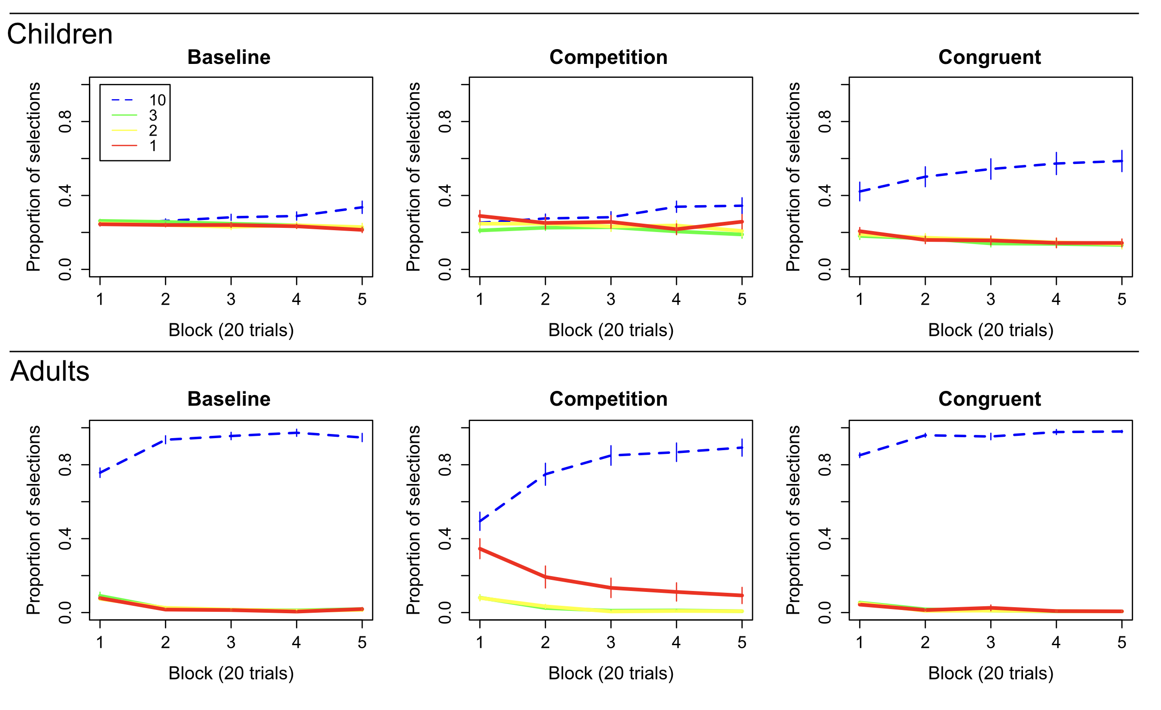

Figure 2: Choice proportions. The proportion of trials on which each option was chosen is presented for blocks of 20 trials. Children in the Congruent condition selected the highest valued option more frequently than children in both the Baseline and Competition conditions. Interestingly, children in the Competition condition did not select the lowest valued option (which was salient in that condition) more often than in the Baseline condition. This suggests that simple salience-seeking did not drive children’s choices. Adults exploited the highest value option in all conditions and selected the lowest option more often when it was salient (in the Competition condition). Error bars reflect standard errors of the mean.

A 3x2 (age by condition) ANOVA on switch proportions revealed a main effect of age group, F(1,212)=577.83, p<0.001, partial-η²=0.73, a main effect of condition, F(2,212)=17.86, p<0.001, partial-η²=0.14, and a significant interaction, F(2,212)=12.50, p<0.001, partial-η²=0.11. For adults, switching was low overall (M=0.117), and there was no effect of condition on the proportion of switching responses, F(2,105)=1.90, p=0.154, η²=0.03.
Importantly, children’s switch proportions were affected by the saliency manipulation, indicated by a significant effect of condition, F(2,107)=17.42, p<0.001, η²=0.25. Children in the Congruent (M=0.56), t(71)=5.57, p<0.001, d=1.30, and Competition conditions (M=0.77), t(71)=3.22, p=0.002, d=0.75, switched substantially less than Baseline (M=0.91). Additionally, children in the Competition condition switched more than those in the Congruent condition, t(72)=3.04, p=0.003, d=0.71. It is not surprising switching was low in the Congruent condition since children were exploiting the best option. But, it is surprising that switching was affected in the Competition condition despite no increase in exploitation.

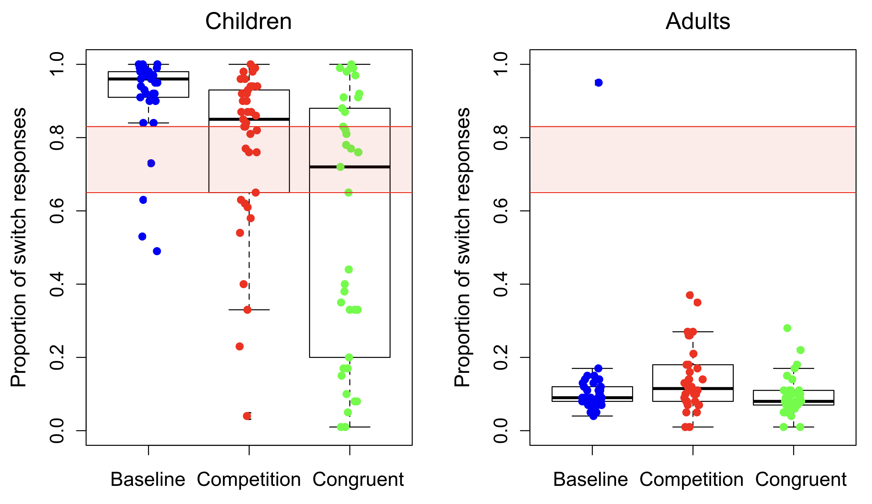
Figure 3: Response Switching. The proportion of trials on which participants made a switch response, choosing a different option than the previous trial, is presented. The pink shaded region represents 95% probability density of switch responses given random responding. Extreme switch proportions for children in the Baseline condition suggest elevated exploration levels. Children’s switch proportions are less than the Baseline in both salience conditions. In contrast, adults rarely switch, instead exploiting the best option. Dots represent individual participants.

Computational Modeling
In order to examine the effects of the salience manipulation on systematic exploration, participants’ choices were evaluated in relation to a Reinforcement Learning model (Sutton & Barto, 1998) that included the potential for both systematic and random exploration (Blanco & Sloutsky, 2019 Preprint). The model used prediction errors to learn expected reward values for each option using the following equation:
$$V_{i,t+1}= V_{i,t}+ α\left(R_{i,t}- V_{i,t}\right)$$

where V_{i,t} is the expected value of option i on trial t, R_{i,t} is the reward on trial t earned for choosing option i, and α is the learning rate (a free parameter). It then made choices according to the following function:

$$P\left(a_{i,t}\right)= \frac{e^{{β*[V}_{i,t}*\left(1-\right)+L_{i,t}*]}}{\sum_{j=1}^{n}{e^{{β*[V}_{j,t}*\left(1-\right)+L_{j,t}*]}}}$$

where P(a_{i,t}) is the probability of choosing option i on trial t. L_{i,t} is the lag term—a proxy for uncertainty—that simply encodes the number of trials since option i was last chosen. The weight parameter φ (0 ≤ φ ≤ 1) mediates the relative weights of expected values (i.e. exploitation) and lags (i.e. systematic exploration) in determining choices. Greater values of φ indicate greater influence of systematic exploration. When φ is 0, the model chooses based only on expected value; when φ is 1 it chooses only based on the lag. β is the inverse temperature parameter that controls random exploration. At β = 0 choice probabilities become completely random (i.e. equal between all options), and as β approaches infinity the model chooses the most favorable option (based on the weighted combination of value and lag described above) on every trial. β and φ were free parameters.

Pai,t= eβ*Vi,tj=1neβ*Vj,t

The best-fitting parameter values were compared across groups and conditions to determine the influences of reward, systematic switching, and random exploration in determining participants choices (see Figure 4). A 3x2 (age by condition) ANOVA on best-fitting φ found a main effect of age group, F(1,212)=82.11, p<0.001, partial-η²=0.28, a main effect of condition, F(2,212)=9.61, p<0.001, partial-η²=0.08, and a significant interaction, F(2,212)=6.92, p=0.001, partial-η²=0.06. Specifically, for adults there was no effect of condition, F(2,105)=1.62, p=0.20, η²=0.03, whereas for children, there was an effect of condition, F(2,107)=8.80, p<0.001, η²=0.14, such that best-fitting φ was higher for the Baseline condition compared to both the Congruent, t(71)=4.36, p<0.001, d=1.02, and Competition conditions, t(71)=2.47, p=0.016, d=0.58. The Congruent and Competition conditions were not significantly different, t(72)=1.56, p=0.123, d=0.36. The high values of φ in the Baseline condition and substantially lower values in both the Congruent and Competition conditions suggest that the salience manipulation dramatically decreased systematic exploration in in these conditions compared to the Baseline.
A 3x2 (age group by condition) ANOVA on best-fitting β (Figure 5) found no main effect of group, F(1,212)=0.14, p=0.708, partial-η²<0.001, no effect of condition, F(2,212)=1.57, p=0.211, partial-η²=0.015, and no interaction, F(2,212)=0.38, p=0.688, partial-η²=0.003.

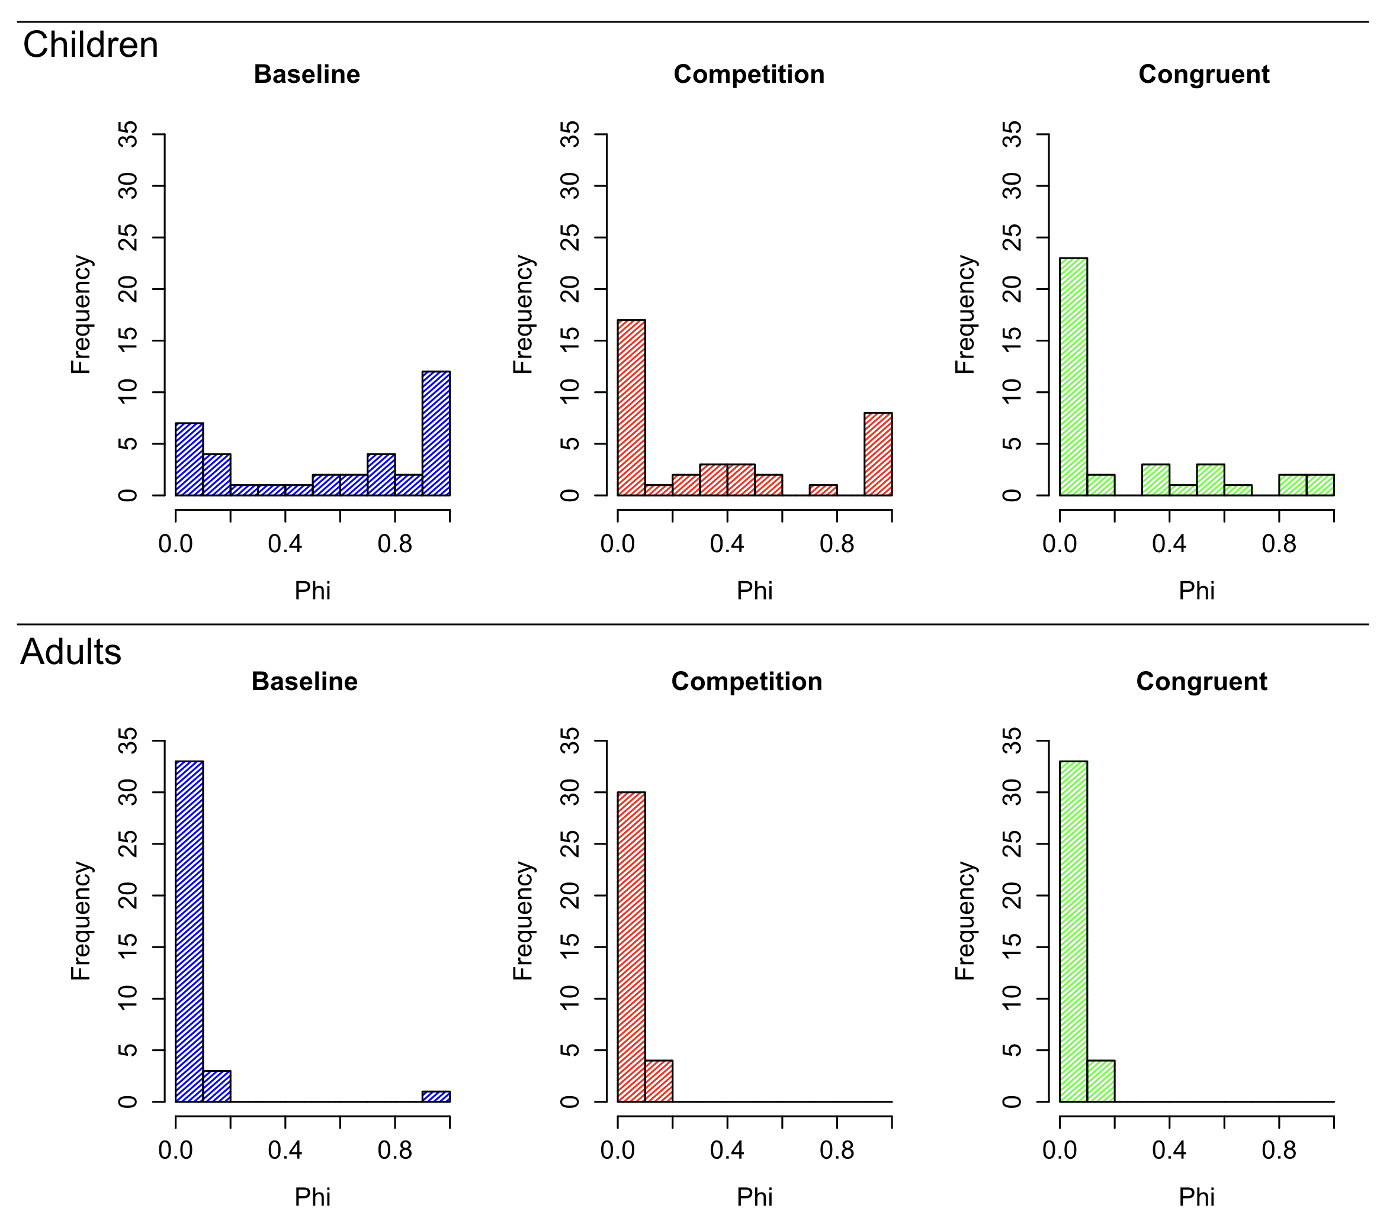
Figure 4: Best-fitting φ parameter. Histograms of the best-fitting φ parameter for each group are presented. Both salience conditions had a large proportion of children with very low values of φ, indicating little systematic exploration, while the Baseline condition had a larger proportion of participants with high values of φ, indicating higher levels of systematic exploration. Almost all adults had low φ, indicating their choices were largely driven by reward value.
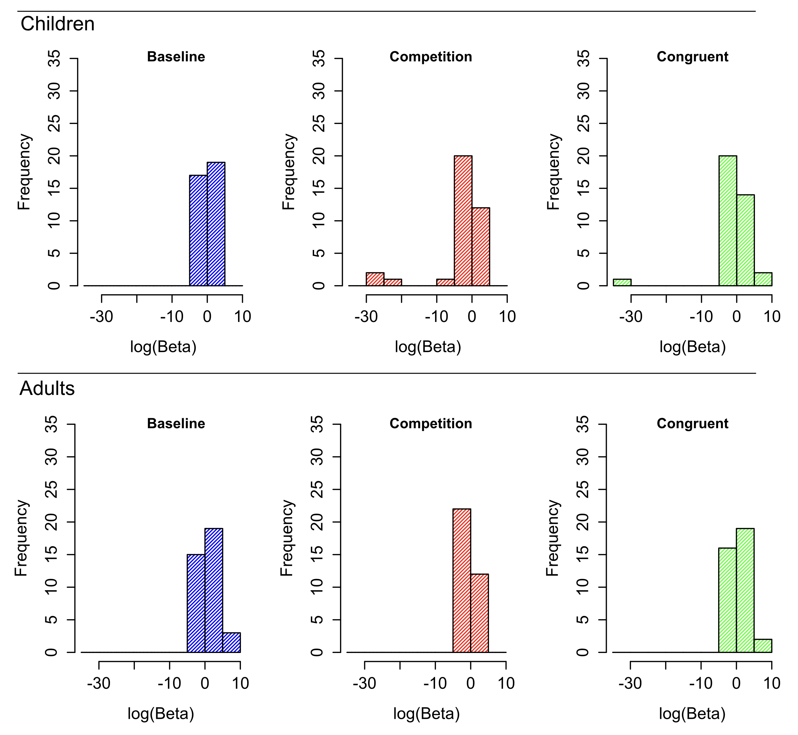
Figure 5: Best-fitting β parameter. Histograms of the log of best-fitting β (which controls the rate of random exploration) are presented. Log(β) is presented rather than raw values because large outliers make graphing the raw values difficult. There were no significant age or group effect on best-fitting β value.

Discussion
The goal of the current study was to examine the link between children’s systematic exploration and attention by manipulating attention and observing effects on children’s choice patterns. The reported results suggest that attentional manipulation (i.e., exogenously capturing attention through large differences in salience) decreased the level of systematic exploration in young children (compared to a Baseline condition).
In addition, children’s choices were not simply salience-driven; instead the effect of saliency was dependent on whether or not salience was congruent with reward value. When the salient option was also highly valuable, children chose it more often than in the other conditions. But, when the salient option was low in value, it was not chosen more (or less) often than in the other conditions. Neither was it selected less often than the other options, suggesting that the results were not simply due to saliency facilitating learning. This interaction suggests a complex role of attention in determining young children’s choices.
When salience is otherwise equal among the options, systematic exploration dominates choices (as in the Baseline condition), with less recently sampled options more likely to be selected. It may be that children’s default attention allocation pattern enables systematic exploration through graded novelty preference (wherein novelty steadily increases over time as an option is not selected, becoming more likely to attract attention). Manipulating bottom-up attention disrupts this process by altering the relative saliency of the various choice options, leading to a reduction in systematic choice patterns.
These results point to an integral role of young children’s immature attentional allocation in facilitating systematic exploratory, in contrast to adults’ tendency to both selectively attend and maximize reward. Attention and decision-making may be intricately linked in both children and adults (Konovalov & Krajbich, 2016; Smith & Krajbich, 2018), and development of attention may be an important factor in the development of choice behavior.
Children’s increasing ability to focus attention selectively may coincide with an increase in maximizing their choices toward rewarding actions. Younger children’s choices seem to be largely geared toward learning rather than maximizing reward, as indicated by several recent findings showing that despite knowing the most valuable option children are less likely than adults to maximize their choices toward it (Plate et al. 2018; Blanco & Sloutsky, 2019 Preprint).
Understanding the critical and complex interaction of attentional mechanisms and decision-making is an exciting area of future research and may be particularly important factor in understanding cognitive development.

Acknowledgments
This research was supported by National Institutes of Health Grants R01HD078545 and P01HD080679 to V. M. Sloutsky. We thank Alicia Scimeca and members of the Cognitive Development lab for their help with this project.

References
Akaike, H. (1974). A new look at the statistical model identification. IEEE transactions on automatic control, 19(6), 716-723.
Badre, D., Doll, B. B., Long, N. M., & Frank, M. J. (2012). Rostrolateral prefrontal cortex and individual differences in uncertainty-driven exploration. Neuron, 73(3), 595-607.
Blair, M. R., Watson, M. R., & Meier, K. M. (2009). Errors, efficiency, and the interplay between attention and category learning. Cognition, 112(2), 330-336.
Blanco, N. J., Love, B. C., Cooper, J. A., McGeary, J. E., Knopik, V. S., & Maddox, W. T. (2015). A frontal dopamine system for reflective exploratory behavior. Neurobiology of learning and memory, 123, 84-91.
Blanco, N. J., & Sloutsky, V. M. (2019). Adaptive flexibility in category learning? Young children exhibit smaller costs of selective attention than adults. Developmental Psychology. http://dx.doi.org/10.1037/dev0000777
Blanco, N. J., & Sloutsky, V. (2019, August 5). Systematic Exploration and Uncertainty Dominate Young Children’s Choices. PREPRINT. https://doi.org/10.31234/osf.io/72sfx

Bunge, S. A., Dudukovic, N. M., Thomason, M. E., Vaidya, C. J., & Gabrieli, J. D. (2002). Immature frontal lobe contributions to cognitive control in children: evidence from fMRI. Neuron, 33, 301-311. https://doi.org/10.1016/S0896-6273(01)00583-9
Casey, B. J., Giedd, J. N., & Thomas, K. M. (2000). Structural and functional brain development and its relation to cognitive development. Biological Psychology, 54, 241-257. https://doi.org/10.1016/S0301-0511(00)00058-2

Chong, S. C., & Treisman, A. (2005). Attentional spread in the statistical processing of visual displays. Perception & Psychophysics, 67, 1–13.
Daw, N. D., O'doherty, J. P., Dayan, P., Seymour, B., & Dolan, R. J. (2006). Cortical substrates for exploratory decisions in humans. Nature, 441(7095), 876-879.
Deng, W. S., & Sloutsky, V. M. (2015). The development of categorization: Effects of classification and inference training on category representation. Developmental Psychology, 51(3), 392-405.
Deng, W. S., & Sloutsky, V. M. (2016). Selective attention, diffused attention, and the development of categorization. Cognitive Psychology, 91, 24-62.
Frank, M.J., Doll, B.B., Oas-Terpstra, J., & Moreno, F. (2009). Prefrontal and striatal dopaminergic genes predict individual differences in exploration and exploitation. Nature Neuroscience, 12, 1062–1068.
Gottlieb, J. (2012). Attention, learning, and the value of information. Neuron, 76(2), 281-295.
Kakade, S., & Dayan, P. (2002). Dopamine: Generalization and bonuses. Neural Networks, 15, 549–559. doi:10.1016/S0893-6080(02)00048-5
Konovalov, A., & Krajbich, I. (2016). Gaze data reveal distinct choice processes underlying model-based and model-free reinforcement learning. Nature communications, 7.
Knox, W. B., Otto, A. R., Stone, P., & Love, B. (2012). The nature of belief-directed exploratory choice in human decision-making. Frontiers in psychology, 2, 398.
Otto, A. R., Knox, W. B., Markman, A. B., & Love, B. C. (2014). Physiological and behavioral signatures of reflective exploratory choice. Cognitive, Affective, & Behavioral Neuroscience, 14, 1167–1183.
Plate, R. C., Fulvio, J. M., Shutts, K., Green, C. S., & Pollak, S. D. (2018). Probability Learning: Changes in Behavior Across Time and Development. Child Development, 89, 205-218. doi: https://doi.org/10.1111/cdev.12718
Plebanek, D. J., & Sloutsky, V. M. (2017). Costs of selective attention: when children notice what adults miss. Psychological Science, 28(6), 723-732.
Plebanek, D. J., & Sloutsky, V. M. (2019). Selective attention, filtering, and the development of working memory. Developmental science, 22(1), e12727.
Posner, M.I., & Rothbart, M.K. (2007). Research on attention networks as a model for the integration of psychological science. Annual Review of Psychology.58, 1-23.
Rehder, B., & Hoffman, A. B. (2005). Eyetracking and selective attention in category learning. Cognitive Psychology, 51(1), 1-41.
Smith, L. B., & Kemler, D. G. (1977). Developmental trends in free classification: Evidence for a new conceptualization of perceptual development. Journal of Experimental Child Psychology, 24(2), 279-298.
Smith, S. M., & Krajbich, I. (2018). Attention and choice across domains. Journal of Experimental Psychology: General, 147(12), 1810-1826
Somerville, L. H., Sasse, S. F., Garrad, M. C., Drysdale, A. T., Abi Akar, N., Insel, C., & Wilson, R. C. (2017). Charting the expansion of strategic exploratory behavior during adolescence. Journal of experimental psychology: general, 146(2), 155.
Sowell, E. R., Thompson, P. M., Holmes, C. J., Jernigan, T. L., & Toga, A. W. (1999). In vivo evidence for post-adolescent brain maturation in frontal and striatal regions. Nature neuroscience, 2(10), 859-861.

Sutton, R. S., & Barto, A. G. (1998). Reinforcement learning: An introduction. Cambridge: MIT press.
Wright, J. C., & Vlietstra, A. G. (1975). The development of selective attention: From perceptual exploration to logical search. In Advances in child development and behavior (Vol. 10, pp. 195-239). JAI.

